Create VLSM for the following:

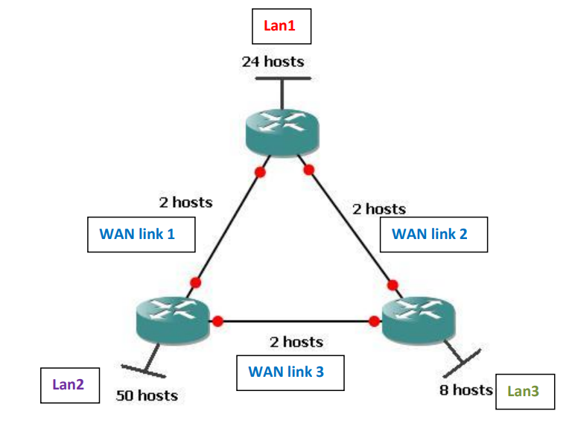

Use IP address 205.15.43.0/24.

Install Cisco Packet Tracer.

Create a network containing one client and one server machines.

Create a page named cdac.html on the server.

Access it from the client.

Ping the client from the server and the server from the client.